

**Springboard 2025**

**Course Funding Proposal**

Please consult [www.setu.ie/sb2025](http://www.setu.ie/sb2025) for information and resources

to support completion of this form.

Please return completed form - including costings agreed with Finance –

to [neil.quinlan@setu.ie](mailto:neil.quinlan@setu.ie) by Friday 21st February 20225



**Please enter general information relation to the course proposal. All sections must be answered.**

Top of Form

|  |
| --- |
| **Please tick which type of funding you are applying for:**  Choose an item. |
| **If you have applied for a Micro-credential course, please confirm if the proposal is a module(s) of a Springboard+ part time or ICT Skills Conversion course that you are also seeking funding for as part of Springboard+ 2025?**  Choose an item. |
| **Course title**: |
| **Level:** Choose an item. |
| **ECTS Credits:** |
| **Skills category:***please choose one option from the pull-down menu only – the HEA web Portal won’t take any other terms / text.*  Choose an item. |
| **ISCED code:**  *Please choose from the codes listed in Appendix indicting the codes deemed eligible for funding by the HEA.* |
| **Number of Semesters:** |
| **Mode of Delivery:** *please choose one option from the pull-down menu only – the HEA web Portal won’t take any other terms / text.*  Choose an item. |
| |  | | --- | |  | | Please confirm that you have engaged with the South East Regional Skills Forum in the drafting of this proposal | |  | |

Bottom of Form

**Please enter details relating to course description, enterprise engagement, recruitment and target cohorts, delivery and other relevant details.**

Please ensure this section addresses the following:  
- Clearly identify how the course will facilitate participants to obtain labour market relevant skills.  
- How have you engaged with enterprise in the development of this course? Please provide evidence of the enterprise demand for the course.  
- Please provide evidence of demographic demand at a regional and national level sufficient to run this course successfully?  
- How have appropriate Target Cohorts been identified?

This is the critical section to make the case for funding:  
- the first sentence needs to sum up how this course will deliver skills SE industry needs in one or more of the prescribed areas;  
- need to prominently reference key national / regional skills strategy docs or reports that provide objective evidence industry context / skills needs for SE for 2025-27;  
- more journalistic style of a popular professional/scientific journal rather than a formal academic journal article that is heavy on academic citations at expense of the narrative flow.

*Maximum Allowed:* ***500 words****:*

* *the HEA web portal will cut text off in mid-sentence if you go over 500;*
* *for quick word count high-light the text and word count will display at bottom left of screen*

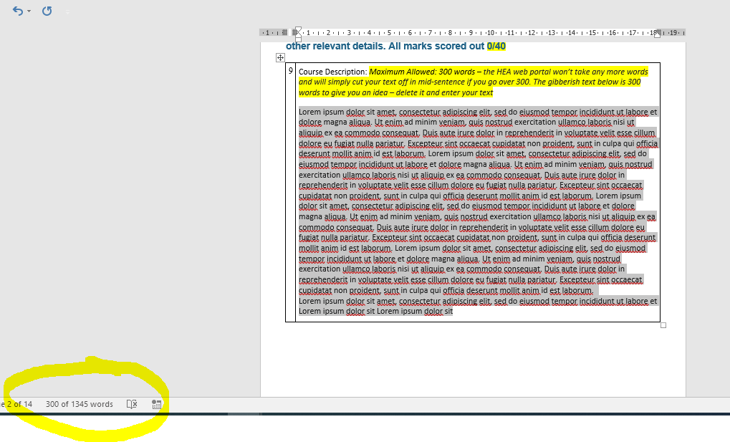

Top of Form

|  |
| --- |
| **Course Description – 500 Words Max** |

**Module Description**

|  |
| --- |
| **List all modules, separate using numbering**  **Example:** *Module Title 1:* [Insert title of module 1] *Module Title 2:* [Insert title of module 2] |
| *Module Title 1:*  *Module Title 2:*  *Module Title 3:*  *Module Title 4:*  *Module Title 5:*  *Module Title 6:*  *Module Title 7:*  *Module Title 8:*  *Module Title 9:*  *Module Title 10:*  *Module Title 11:*   *Module Title 12:*  *Etc.* |

|  |
| --- |
| **Description of Each Module**  Briefly describe all modules as numbered above. A total cap of 500-words is applied under this entire field.  Example: Module Title 1: [Briefly describe module 1] Module Title 2: [Briefly describe module 2] Etc. |
|  |

|  |
| --- |
| **Confirmation of Start**  **I confirm that this course and all intakes (if applicable) will commence between 1st July 2025 and 31st October 2025. Please note, no courses or intakes can commence outside this timeframe.** |

**Course Delivery Modes**

|  |  |
| --- | --- |
| **Mode**  Note: per HEA definition **“Online** refers to live lectures/classes which can be accessed remotely by learners, whereas **E-Learning** relates to self-directed learning with pre-recorded lectures/classes or other lesson tools. | **% in this mode  [ column total must be 100% ]** |
| Blended Percentage |  |
| Classroom Percentage |  |
| E-learning Percentage |  |
| Online Percentage |  |

|  |
| --- |
| **Has this course been offered through Springboard+ in previous years?:** |
| If yes, please specify years it was offered:  [ please use only this list – the HEA web Portal won’t take any earlier years ]  2017/2018 2018/2019 2019/2020  2020/2021  2021/2022  2022/2023  2023/2024 |

**Intakes**

|  |
| --- |
| **Campus:** |
| **Description:** 200 words max   * If the description of the does not differ from the “Course Description” as requested earlier in the form, providers can detail N/A under this field or give a brief re-statement of the course you’re proposing if you wish. There is no requirement to repeat the same information if this information is already detailed under the field “Course **Description**”. * If more than one intake please add further rows as above in order to detail all intakes individually – for example there may be different intakes being delivered in different campus locations etc. |
| *.* |

|  |
| --- |
| **Total Proposed Student Enrolment Numbers (all intakes):** |
| **Number of Contact Hours per Week** *[ must be less than 17 to qualify for Springboard]:* |
| **Entry requirement for applicants**.  Please use the most current official version of the academic entry requirements on record with Registry – this is the only ‘legal’ version of the requirements and needs to be the one used in this publically funded and public process. If you don’t have the final approved version of the entry requirements please consult your faculty administration or registry. |
| Official SETU Entry Requirements text: |
| Periods in which contact hours will take place:  *[ please use only the pull-down menu – the HEA web portal won’t take any text – just one of these options ]* |
| Course Coordinator / Contact : |
| Coordinator Email : |
| Coordinator Phone Number: |

**Please enter details relating to supports for course participants**

Top of Form

|  |
| --- |
| **Does the programme provide a job readiness element?**  Choose an item. |
| If yes, please provide **details regarding job readiness**, including whether this is credit bearing, and the proportion of the course being allocated to this component:  Maximum allowed 200 Words |

**Course Costs**

Please note that assessment of costs and value for money is competitive and will be made with reference to the costs for Springboard/similar courses previously approved. Please:

* see costing information at [www.setu.ie/sb2025](http://www.setu.ie/sb2025)
* go through Costing with Brian O’Reilly (WD) and Finance Office in Carlow before submission

Top of Form

|  |
| --- |
| I confirm that SETU Finance office has signed-off on these course costings:  Choose an item. |
| Total cost of delivering course (Springboard cohort only) (€): |
| Total Enrolment target number students for course: |
| Number of ECTS credits awarded: |
| Cost per student (€): |

# **Eligible Learner Assessment**

Information required by the HEA for the purposes of administering the programme. This information will not form part of the assessment.

Please outline briefly the process you will employ to assess candidate’s eligibility, aptitude and suitability for the course (100 words)

|  |
| --- |
| Possible draft text :  *The Springboard Team check/follow-up on evidence of funding eligibility as regards nationality, residence, employment status etc. The Team uploads academic eligibility/aptitude evidence presented by candidates to an online folder shared with the academic team who screen for evidence of academic eligibility and aptitude – with the SB Admin team working back with candidates to request further documentation including RPL as required. Candidates rolling application status is documented on a shared spreadsheet. Following the initial closing date the SB Team may issue offers to candidates approved by the course academic team.*  *[ feel free to edit if you do interviews etc. – but keep in mind the 100 words limit. ]* |

# **Further Mandatory Information**

|  |
| --- |
| **HCI Pillar 3 Micro-Credentials Learner Fee Subsidy**  Please confirm if this course received funding under the HCI Pillar 3 Micro-Credentials Learner Fee Subsidy?  Choose an item. |
| **Renewable Offshore Wind Energy Skills Area**  Please confirm if this course should be considered for Renewable Offshore Wind Energy funding?  Choose an item.  ISCED Code: 0712 Environmental protection technology. |
| **United Nations Sustainable Development Goals (SDGs)**  Detail how this course will address the United Nations Sustainable Development Goals (SDGs).  This should include details of how SDGs are addressed in the course development, course implementation, consultations with appropriate stakeholders, and in supports and resources for staff and students. |
| *< Max 250 words >* |

# **Appendix: Eligible Discipline Areas (ISCED Codes)**

0211 Audio-visual techniques and media production

Audio Visual, Media, Animation, Games Development

0212 Fashion, interior and industrial design

Need for design skills - product design, design innovation, creative design

0231 Language Acquisition

Languages for sales and customer services

0313 Psychology

Buyer behaviour, smart leadership

0410 Business and administration not further defined

Stock Management, Quality Management, Supervisory Practice, Payroll, E commerce, Supervisory Practice

0412 Finance, banking and insurance

Data Analytics Financial, Fintech, Regulation, Compliance and Risk, International Fund admin, Insurance, Data Governance, Lineage & Architecture, Asset Management, Investment Funds & Securities Services, Insurance and Reinsurance, Wholesale Capital Markets, International Banking, Fintech & Payments, Aircraft Leasing & Finance, Creative Arts Management, Anti Money Laundering, Data Visualisation, Data Analytics for Users

0413 Management and Administration

Business internationalisation, Business management, Lean fundamentals, International Trade and customs, Leadership, Supervisory Management, Entrepreneurship, Innovation, Creativity, Design thinking, Strategic Planning, Human Resource Management, Change Management, Business Process Optimisation

0414 Marketing and Advertising

Marketing in a digital world, Virtual Selling, Selling Strategies, Digital marketing for SMEs

0417 Workskills

Resilience skills, Inclusion and diversity, Critical Creative thinking, Entrepreneurship, Transversal, Workforce Development, Talent Management, Coaching, Wellness

0419 Business and administration not elsewhere classified

HR Management, Talent Development

0421 Law

Company Law, Corporate Administration, Corporate Secretarial

0488 Inter-disciplinary programmes and qualifications involving business, administration and law

Procurement, Purchasing Tendering, Customer Experience

0511 Biology

Cell culture, Analytical Microbiology

0512 Biochemistry

Pharmaceutical Technology, Biopharmaceutical Analysis, Validation, Sterilisation Therapy, Chromatographic techniques, Advanced Spectroscopy

0519 Biological and related sciences not elsewhere classified

International Regulatory affairs, Good Manufacturing Practice, Quality Management Biopharma/Pharma

0521 Environmental Sciences

Sustainability, Biocircular economy, Climate Change, Energy sustainability, Business sustainability, Introductory ESG for corporates/directors/board members, Applied Renewables for qualified trades/engineers, Environmental Impact Assessment, Environmental Policy including CSRD Reporting

0531 Chemistry

Analytical Science, Drug formulation, Advanced Materials, Industrial instrumentation, Calibration and advanced PLC

0542 Statistics

Statistics

0588 Inter-disciplinary programmes and qualifications involving natural sciences, maths and stats

Data Analytics, Business Information Systems, Validation & CSV, Data Analytics for Non-Data Analysts

0610 Information and Communication Technologies (ICTs) not further defined

Information System Design / Interactive Design

0612 Database and network design and administration

Big data, Data Science, Data analytics, Networking systems, Maintenance Systems, Service Design

0613 Software and applications development and analysis

Cloud Technologies, Software Development Technologies, Mobile Technology, Programming, Software Engineers, AI for Software Engineers, Automated Software Testing, Machine Learning

0619 Information and Communication Technologies (ICTs) not elsewhere classified

ICT Systems, Business Systems, Cybersecurity, Digital Forensics, Dev Ops, Cybersecurity and Artificial Intelligence, Applicability of AI in an industry/enterprise setting

0688 Inter-disciplinary programmes and qualifications involving Information and Communication Technologies (ICTs)

Product Management for Product Owners, Twin Transition, Digitalisation

0700 Engineering, manufacturing and construction not further defined

Good Manufacturing Practice, Process Safety, Lean systems and New Product Design- move

0710 Engineering and engineering trades not further defined

Building Services Engineering, Fire Engineering

0711 Chemical engineering and processes

Chemical Process Engineering Technologies

0712 Environmental protection technology

Water and Waste Water Management, Renewable Offshore Wind Energy

0713 Electricity and energy

High and Medium Voltage Electrical Engineering, Renewable Energy, Industrial Electricity, Sustainable Energy Engineering

0714 Electronics and automation

Industry 4.0/5.0, Automation Engineering, Advanced PLCs, Automation and Control, Autonomous Vehicles, Robotics, Mechatronics, Fundamentals of AI, Blockchain

0715 Mechanics and metal trades

Manufacturing Engineering

0716 Motor vehicles, ships and aircraft

Aviation, Leasing

0719 Engineering and engineering trades not elsewhere classified

Estimating for Mechanical and Electrical Engineering, Quality Engineering, Polymer processing

0720 Manufacturing and processing not further defined

Lean and Sigma, Introduction to best manufacturing Practice, Smart Manufacturing IOT, Production Management for all types of Manufacturing, Quality Technician for Medtech

0721 Food processing

Food Safety, Food Hygiene, Food Science, Food Manufacturing, Food Innovation/ Entrepreneurship, New Product Development

0723 Textiles (clothes, footwear and Leather)

Textile Manufacturing

0729 Manufacturing and processing not elsewhere classified

Process optimisation & LEAN – people, process technology

0732 Building and civil engineering

Construction Site Management, Computer Aided Design CAD, Building Information Modelling BIM incl MEP Applications, NEAR Zero Energy Buildings NZEB, Retrofitting, Utilities Design, Modern Methods of Construction, Construction/Sustainable Built Environment

0788 Inter-disciplinary programmes and qualifications involving engineering, Manufacturing and construction

ESG for Management, renewables as add on for engineers/trades

0799 Engineering, manufacturing and construction not elsewhere classified

0819 Agriculture not further defined or elsewhere classified

0821 Forestry

Professional forester

0914 Medical diagnostic and treatment technology

Medical Technology, Medical Devise Design, Product Design

0916 Pharmacy

Pharmacy Technician

0919 Health not elsewhere classified

Health informatics, Innovation, Interaction Design, Service Design

1013 Hotel, restaurants and catering

Culinary Skills/Arts, Chef, Revenue Management, Hotel Management

1015 Travel, tourism and leisure

Destination Leadership, Tourism and Travel

1022 Occupational health and safety

Occupation and Process health and Safety

1041 Transport services

Logistics, Supply chain, Transport Management, Freight Forwarding, Customs and Global Trade (Incl Brexit)

Bottom of Form

Bottom of Form